

Installation Instructions

Insum

Single Sign On Engine

Post Clone Steps

Author: Sylvain Martel

Creation Date: May 23, 2016

Last Updated: March 23, 2017

Document Ref: EBS-APEX

Version: 1.0.1

1. **Title, Subject, Last Updated Date, Reference Number**, **and** **Version** are marked by a Word Bookmark so that they can be easily reproduced in the header and footer of documents. When you change any of these values, be careful not to accidentally delete the bookmark. **You can make bookmarks visible by selecting Tools->Options…View and checking the Bookmarks option in the Show region.**

## Document Control

**Change Record**

3

| Date | Author | Version | Change Reference |
| --- | --- | --- | --- |
|  |  |  |  |
| 23-May-16 | Sylvain Martel | 1.0.0 | Initial Release |
| 23-Mar-17 | Sylvain Martel | 1.0.1 | Review for Open Source |
|  |  |  |  |
|  |  |  |  |

**Reviewers**

| Name | Position |
| --- | --- |
|  |  |
| Daniel Boudreault | APEX Database Administrator |
|  |  |
|  |  |
|  |  |

.

Contents

Document Control ii

APEX Instance - Post Clone Steps 1

Insum-C2 Single Sign On URL 1

1. To update the table of contents, put the cursor anywhere in the table and press [F9]. To change the number of levels displayed, select the menu option Insert‑>Index and Tables, make sure the Table of Contents tab is active, and change the Number of Levels to a new value.

## APEX Instance - Post Clone Steps

### Insum-C2 Single Sign On URL

Update the default URL where the APEX engine is located in for the single sign on (SSO) engine to connect to the right APEX instance.

Once updated, you will be able to broadcast that URL to all the existing partnership in the SSO engine.

**From the APEX Builder**

From your favorite browser, go to the Insum-C2 SSO Administration application.

Example: [http://*servername:port*/apex/f?p=SSO_ADMIN](http://servername:port/apex/f?p=SSO_ADMIN)

1. Click on the Default Values link in the menu list:
2. 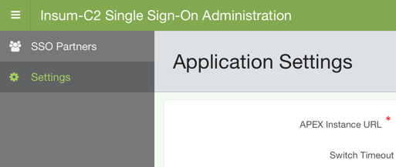
3. Enter the new URLs for **APEX Instance URL**, **Invalid login URL** and **Username mismatch URL**:

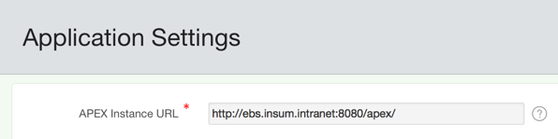

**IMPORTANT:** Make sure the URL ends with a forward slash.

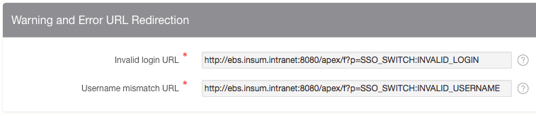

1. Click on the **Apply Changes** button
2. Click on the **Broadcast New URL to All** button



**End of document.**